Scripts for Scene: **WTInside_Cantilever3**

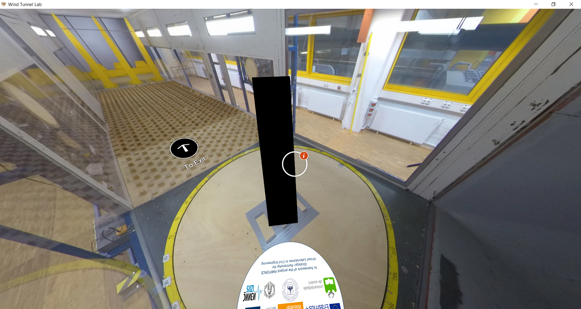

|  |  |  |
| --- | --- | --- |
| Nr | Hotspot (see red arrow) | Script |
| 1 | Hotspot: Cantilever cylinder model | Slide pictures/Album (with text):  Slide 1-Figure :    Slide-1 Text:  Two circular cylinders in-line model (2-in-line) stood as the one of the configurations the campaign of grouped cylinder experiments. Other configurations such as 2x2, 4-in-line, and 2x1 are also investigated in this wind tunnel project. The model has height H = 930 mm from the ground of wind tunnel chamber and diameter of D = 50 mm. It is constructed with a carbon tube, covered by a Styrofoam coat. On the surface of the model, a properly distributed sand-grain roughness is placed on all the surfaces of the cylinder to create a rough cylinder characteristic on Reynolds number regime. This model is a reduced scale of a real wind turbine tower. The model is fixed at the base to a force balance. The distance between two model to the diameter ratio is 1.25.  Slide-2 Figure:    Slide-2 Text:  Why should the model use an additional roughness? Where the real wind turbine tower has a very smooth surface in the reality. This is because of the smaller diameter of the model, due to scaling. When a scaled model is used, and smaller dimension of the model is used, the Reynolds number change. This means the flow regime changes because the Reynolds number is different. (Source figure: ESDU 80025)  Slide-3 Figure:    Slide-3 Text:  Increasing roughness of the surface of a body will make a change in the Reynolds number effect. As displayed in the figure, body with rougher surface, will have tighter curve (smaller range of drag crisis) and it reaches the later regime in smaller Reynolds numbers. Note that the diameter of the real wind turbine tower ranges around 4-6 m of the adapted case. This means, in reality, the transcritical flow occurred around the wind turbine tower. By increasing the roughness, the transcritical flow can be reproduced in the wind tunnel despite having smaller diameter and smaller Reynolds numbers. Different flow regime means that different behavior of drag, lift and Strouhal number will take place. (Source Figure: Niemann, 1990)  Slide-4 Text:  References:  [1] ESDU 80025: “Mean forces, pressures and flow field velocities for circular cylindrical structures: Single cylinder with two-dimensional flow”. Engineering Science Data Unit, 2006  [2] H.J. Niemann, N. Hölscher. 1990. A review of recent experiments on the flow past circular cylinders. Journal of Wind Engineering and Industrial Aerodynamics, Vol. 33 Issues 1-2, pages 197-209.  How the slide Figure is displayed: |
| 2 | Hotspot: Mounting of the model | Script Only:  The model is mounted and fixed at the base to the force balance. The force balance sensor will measure the response at the base. Further information of the force balance can be seen in the Control Room and outside of the wind tunnel chamber. |
| 3 | Hotspot: Evaluation of the response of the tower | Figure+Text:  Figure:    Text:  Obtaining the oscillation of the model is one of the main objectives of the experimental campaign of grouped cylinders. Oscillation at top can be calculated during the test with wind from the forces or bending moments measured at the base. In the case of resonance, when the vortex shedding frequency is around the natural frequency of the model, the reaction at the base is caused by the distribution of initial forces along the height. This then allows the derivation of the displacement at the top from the reaction at the base. (Source Figure: F. Lupi, 2019)  Reference: F. Lupi. Across wind actions (vortex shedding). Lecture notes. Ruhr-University Bochum, 2019. |
| 4 | Hotspot: Experiment result – Movement of the grouped cylinders 2-in-line, view from above | Slide Videos/Album + label:  (You can reduce the length of videos to 60s to reduce the size)  Slide 1-Video file:  ViewTop_2Cyl_A000_0600.mp4  Slide-1 Label:  “Wind direction 0°”  Slide 2-Video file:  ViewTop_2Cyl_A005_0600.mp4  Slide-2 Label:  “Wind direction 5°”  Slide 3-Video file:  ViewTop_2Cyl_A010_0600.mp4  Slide-3 Label:  “Wind direction 10°”  Slide-4 Video file:  ViewTop_2Cyl_A015_0600.mp4  Slide-4 Label:  “Wind direction 15°”  Slide-5 Video file:  ViewTop_2Cyl_A090_0600.mp4  Slide-5 Label:  “Wind direction 90°” |
| 5 | Hotspot: Experiment result – Movement of the grouped cylinders 2-in-line, view from side | Slide Videos/Album + label:  (You can reduce the length of videos to 60s to reduce it size)  Slide 1-Video file:  ViewSide_2Cyl_A000_0600.mp4  Slide-1 Label:  “Wind direction 0°”  Slide 2-Video file:  ViewSide_2Cyl_A005_0600.mp4  Slide-2 Label:  “Wind direction 5°” |
| 6 | Hotspot: Previous studies as basis of the experiment results – flow around 2-in-line grouped cylinders, the effect of critical wind direction and close spacing between the cylinders | Slide pictures/Album (with text):  Slide 1-Figure :    Slide-1 Text:  The experiment of grouped cylinder in this virtual tour is focused on the 2-in-line arrangement with variation of the incoming wind direction. The distance-to-diameter ratio between the two cylinders is kept at 1.25. This is a small distance that is susceptible to the interference effects. In this hotspot, the previous studies investigated the 2-in-line arrangement as the basis and the reasoning of the experiment results observed in WIST wind tunnel (see videos of the oscillation of the cylinders). (Source Figure: Alam, 2013)  Slide-2 Figure:    Slide-2 Text:  The effect of spacing between two cylinders.  When the other cylinder is placed closely to the other cylinder, the effect of interference exists and based on the given distance, its effect varies on the distance. Please note that the incoming wind direction is also contributing simultaneously. However, for conciseness, only the effect of the distance between cylinder is presented in this paragraph. One of notable study that had investigated the effect of distance between 2-in-line configuration of grouped cylinders is Igarashi (1981). As shown in the figure, the distance-to-diameter ratio L/D of the two cylinders gives different effect of flow patterns around the cylinders. (Source Figure: Igarashi, 1981).  Slide-3 Figure:    Slide-3 Text: More general categorization had also been done by other works (Zdravkovich, 1987, Zhou et al. 2004, 2006, Ljungkrona and Sunden, 1993) by dividing the type of flow pattern into three categories: Extended body, reattachment, and co-shedding regime. Extended body describes the flow that the vortex shedding from first cylinder envelops the second cylinder, as the distance is very close (i.e., L/D=1-2). This means the two body can act as an extended body. Reattachment regime refers to the fact that the boundary layer of the vortex shedding of the first cylinder reattaches on the second cylinder. This gives additional forces on one of the sides of the second cylinder. This usually happens when the distance L/D is around 2-5. Co-shedding regime refers that the two cylinders are placed with enough distance, in which that vortex shedding of each of the cylinder able to completely form. Usually, the distance L/D is larger than 5. Further reading is referred to the references at the end of the slide.  Slide-4 Figure    Slide-4 Text:  The effect of wind direction.  As seen in the recorded videos of the observed oscillation of the two cylinders, the cylinder moves and have higher oscillation at specific nonzero wind direction. This is called a critical wind direction of interference galloping. In such way, when the two cylinders are placed close enough between each other and a certain wind direction comes, the oscillation persist and is self-sustained. Based on previous studies and wind tunnel tests, the critical wind direction on a 2-in-line configuration is predicted to be around 5-10°. (Source Figure: Ruscheweyh, 1983)  Slide-5 Figure:    Slide-5 Text:  The high oscillation can be addressed with the observed value of lift coefficient of the cylinder. Schewe and Jacobs (2019) conducted a wind tunnel experiment on 2-in-line cylinder, where force measurements were performed, in the transcritical Reynolds number range. The different wind direction from -20° to 20° was observed, and nonzero lift coefficient was found around the critical wind direction.  Slide-6 Text:  References:  [1] M. M. Alam, J. P. Meyer. 2013. Global aerodynamics instability of twin cylinders in  cross flow. Journal of Fluid and Structures 41, pages 135-145.  [2] T. Igarashi. 1981. Characteristic of the flow around two circular cylinders arranged  in tandem (1st report). Bulletin of the JSME, Vol. 82, pages 532-582.  [3] M. M. Zdravkovich. 1987. The effects of interference between circular cylinders in  cross flow. Journal of Fluids and Structures, Vol. 1, Issue 2, pages 239-261.  [4] Y. Zhou, M.W. You. 2006. Flow structure, momentum and heat transport in a two-tandem-cylinder wake. Journal of Fluid Mechanics 548, pages 17-48.  [5] L. Ljungkrona, B. Sunden. 1993. Flow visualization and surface pressure measurement on two tubes in an inline arrangement. Experimental Thermal and Fluid Science 6, pages 15–27.  [6] H. P. Ruscheweyh. 1983. Aeroelastic interference effects between slender structures. Journal of Wind Engineering and Industrial Aerodynamics 14, pages 129-140.  [7] G. Schewe, M. Jacobs. 2019. Experiments on the flow around two tandem circular  cylinders from sub- up to transcritical Reynolds numbers. Journal of Fluids  and Structures, Vol. 88, pages 148-166, 2019. |
| 7 | Hotspot: Prandtl Tube | Slide pictures/Album (with text):  Slide 1-Figure :    Slide-1 Text:  Prandtl tube is used to measure the dynamic pressure of the undisturbed flow in the wind tunnel. This will give the information about the undisturbed wind speed. The Prandtl tube can be placed not only on the top wall, but also on the ground of the wind tunnel. For pressure measurement, the pressure of an undisturbed flow is usually used as reference pressure. This means the Prandtl tube will be connected to the box of pressure sensors and gives the reference value for all the pressure sensor channels (See information about the sensors in the control room.). Calibration of the Prandtl tube as reference pressure should be done.  Slide-2 Figure:    Slide-2 Text:  The main goal of the Prandtl tube is to measure the undisturbed velocity pressure, utilizing the concept of stagnation point. In stagnation point, when the flow hits an object, all the kinetic energy is converted into pressure. The wind speed is zero at this point. The pressure at this stagnation point represent all the incoming dynamic pressure from the wind and can be measured.  Slide-3 Figure:    Slide-3 Text:  Prandtl tube then utilizes this concept, which can be demonstrated with “U-tube” mechanism that connects both the stagnation point (2) and undisturbed flow with existing wind speed (3). The difference in pressure between the two points can be measure by the indication shown in height difference in the fluid inside of the U-tube.  Slide-4 Figure:    Slide-4 Text:  The same concept of two different points around the Prandtl tube is used. However, instead of using U-tube, a sensitive membrane is used to measure the pressure difference between two sides. The pressure difference between the points is measured and its value is measured in Volt. (Source figure: <https://www.tec-science.com/>) |
| 8 | Hotspot: Turntable wood plate | Figure+Text:  Figure:    Text:  To able investigating different wind direction, the wood plate where the cantilever model is placed is a turntable. By turning the table, the model is rotated, in which the incoming wind flow will come in different direction from the perspective of the model. The diameter of the turntable is 1.7 m. |